Senedd Cymru-Welsh Parliament Cross Party Group on Hospices and Palliative Care

Chaired by Mark Isherwood MS
Secretariat by Hospice UK

Call for written evidence into experiences of end-of-life care at home and in care homes during the pandemic

Questions

1. How did changes in health and care services during the pandemic affect the delivery of palliative and end of life care for children and adults at home and in care homes?

2. What were the experiences of people receiving end of life care, their families and loved ones at home and in care homes as a result of changes to services?

3. Was there inequality in access to care for people from certain groups dying at home and in care homes during the pandemic?

4. What positive ways of working and innovative approaches to delivering palliative and end of life care at home and in care homes have been developed during the pandemic?

5. What impact has the pandemic had on the health and wellbeing of frontline health and care workers, families and unpaid carers who deliver end of life care in the community and how can they be best supported going forward?

RCGP Answers

- How did changes in health and care services during the pandemic affect the delivery of palliative and end of life care for children and adults at home and in care homes?

RCGP members note the direct impact that cases of COVID-19 had within care homes. COVID-19 disproportionately affected residents of cares homes. In a study of 27 care homes for the elderly conducted by Aneurin Bevan University Health Board, which included 10 care homes with deaths greater 10 residents or then 40% of residents, it was found that 90% residents were subject to DNACPR however holistic care planning was only used in 43% of cases., with no clear escalation plan in 33& of cases.

This study found there was variation between the quality of clinical records and the level of clinical detail was greater, where reviews were conducted by a GP who had an established relationship with care homes through delivery of the Care Homes Enhanced Service. Following the change to the procedure for MCCDs there were 17 cases identified that may have warranted the includes of COVID-19 on the death certificate but where this wasn’t present. The study highlighted the need for the provision of further investigation into the provision of out of hours death certification.

Further info? Equipment issues, access to drugs and syringe drivers?

2. What were the experiences of people receiving end of life care, their families and loved ones at home and in care homes as a result of changes to services?

3. Was there inequality in access to care for people from certain groups dying at home and in care homes during the pandemic?

4. What positive ways of working and innovative approaches to delivering palliative and end of life care at home and in care homes have been developed during the pandemic?

The level of clinical detail was greater where reviews were conducted by a GP who had an established relationship with care homes through delivery of the Care Homes Enhanced Service. In the context of concerns in the media regarding care homes, the lack of detail regarding physical parameters and rationale for clinical management plans is of concern

5. What impact has the pandemic had on the health and wellbeing of frontline health and care workers, families and unpaid carers who deliver end of life care in the community and how can they be best supported going forward?

Our members reported a change at first from 108% capacity down to 90% capacity however by the end of 2020 members reporting an increase in workload to an average capacity of 127%.

Our members also reported a need to seek support for mental with 65% of members needing to speak to a colleague for mental health purposes, 26% using online services such as apps, however only 7% took time off work for mental health during the first 9 months of pandemic.

Still to learn:

- Evidence of experience of palliative care for those not necessarily dying from COVID-19
- Measures taken in primary care for all terminally ill patients, which changed the way care was managed.
- What can our members say about care during covid for children in hospices and those dying at home?
- Anything anecdotal to highlight experiences of families and loved ones of those experiences end of life care between March 2020 and the lifting of restrictions in March 2022
- Any studies on the impact of restrictions on families and those receiving palliative care e.g terminal cancer patients
- Any studies or anecdotal evidence on health and wellbeing of staff
- Equipment issues, access to drugs and syringe drivers caused by COVID

Rough Notes

Further- Notes from Dr Clifford Wyn Jones, Primary Care Director, Aneurin Bevan University Health Board

Key messages:

What was already known? ► COVID-19 disproportionately affected residents of care homes.
► COVID-19 was a real-world test of existing advance care planning (ACP) processes. What are the new findings? ► ACP in care homes may not be applicable to rapidly changing emergency scenarios and did not fully cover the clinical scenarios encountered during COVID-19. What is their significance? Clinical
► Specific plans for deterioration are required to optimally support care home residents. Research
► Applicability of traditional models of ACP in care homes.

Most care home residents are DNA CPR- holistic end of life planning is only present for a minority

Significant number of deaths in the community are accounted for by care home residents

In a review of care homes including 10 care homes where deaths were greater than 10 residents or than 40% of residents it was noted that swab antigen tests were not regularly performed on residents

RESULTS The review(online supplemental file 1) included 136 cases in total and 27 care homes. The key features of the cases reviewed were: ► First presentation was on 5 March 2020 and the first reported death was on 9 March 2020. ► Age ranges from 49 to 102 years, with an average age of 88.4 years. ► During the period of the review, swab (antigen) tests were not routinely performed for suspected COVID-19 cases in care homes, therefore only 16 of the cases were swab positive. Most cases experienced ‘typical’ COVID-19 symptoms of fever and respiratory symptoms. However, >50 cases experienced presenting symptoms not included in government testing guidance. In almost all cases, DNACPR was in place prior to death (90%), but only 43% had ACP (or equivalent). There was no clear escalation plan documented in 33% of cases (figure 1). Professional bodies had issued advice regarding verification of death via video consultation.4 Formal guidance was issued by the Welsh Government on this issue on 15 May 2020 (https://gov.wales/verifyingdeath-times-emergency-coronavirus-covid-19). In the vast majority (100 cases), verification of death was carried out in person by out-of-hours clinicians or the registered General Practitioner (GP), with only eight recorded cases of remote verification. Cause of death entered is a matter of clinical judgement, determined by the patient’s medical history and the circumstances of their death. The rules surrounding the completion of the Medical Certificate of Cause of Death (MCCD) have changed following the Coronavirus Act 2020 (enacted on 25 March 2020).5 6 Seventeen cases were identified that may have warranted the inclusion of COVID-19 on the MCCD. Although some of these deaths may have been due to other causes (eg, dementia), in the context of the COVID-19 pandemic, the mode of death was suggestive of COVID-19.

There were no identified concerns regarding the clinical care and management.

conncerns regarding the clinical care and management. There was variation in approaches to carrying out face-to-face reviews in care homes, and the approaches to obtaining clinical information in lieu of physical examination. Reviewers commented on variation in the quality of clinical records and documentation by primary care teams. The level of clinical detail was greater where reviews were conducted by a GP who had an established relationship with care homes through delivery of the Care Homes Enhanced Service. In the context of concerns in the media regarding care homes, the lack of detail regarding physical parameters and rationale for clinical management plans is of concern.

Following the switch to remote consulting, there were concerns that care homes would be pressurised to support remote verification of death. This was not the case in this review. However, verification of death during the out-of-hours period is a significant demand Figure 1 Presence of DNACPR, ACP and TEP. DNACPR, Do not attempt cardiopulmonary resuscitation; ACP, advance care planning; TEP. treatment escalation planning. on April 27, 2022 by guest. Protected by copyright. http://spcare.bmj.com/ BMJ Support Palliative Care: first published as 10.1136/spcare-2022-003589 on 22 March 2022. Downloaded from Jones CW, et al. BMJ Supportive & Palliative Care 2022;0:1–4. doi:10.1136/spcare-2022-003589 3 Short report on out-of-hours services and facilitation of verification of death by care home staff should be a priority to improve after death care.

the report did not identify any concerns in the verification of death

It was evident that although DNACPR processes are widely applied, this does not extend to ACP. DNACPR, ACP and planning for deterioration (eg, TEP) seem to be conducted in parallel, with no cross-referencing.

hould be a priority for primary care and care homes. Deaths in care homes increased by 134% during the first wave of the COVID-19 pandemic, the greatest relative increase for any recorded place of death.7 The rates of ‘typical’ COVID-19 symptoms within our cohort were consistent with other studies.8 Other studies have highlighted that ACP discussions were disrupted by the COVID-19 pandemic, particularly when discussions needed to involve family and proxy decision-makers.

However, this review was limited to individuals who died in the care homes and does not include individuals who recovered or were admitted to hospital.

From RCGP survey- file:///C:/Users/rmiller/Downloads/future%20role%20of%20remote%20consultations%20patient%20triage.pdf- date?

c. Research from the Health Foundation found that one in three GPs who singlehandedly manage a practice are at high risk or very high risk of death from COVID-19, and that these GPs were more likely to be working in areas of high deprivation.5 (The Health Foundation, (August 2020) ‘How might COVID-19 affect the number of GPs available to see patients in England?’, Fisher, R. and Asaria, M.)

As of mid-March 2021, telephone and video appointments made up 54%of appointments

60% of GPs in an RCGP survey also said that remote consultations are more effective for monitoring and following up with existing patients rather than new patients,7 and they can also be useful for following up once a patient has already been seen for a condition. Every patient is likely to sit somewhere along a spectrum between needing remote and face-to-face care, and this will change according to their needs at any particular time and as symptoms or circumstances change.

What are the concerns about the ‘total triage’ model and widespread use of digital-first platforms? Only 52% of GPs in RCGP’s survey agreed that ‘patients always get where they need to’ through total triage systems, while 58% said it helps to ensure patients’ needs are better met. 42% disagreed that total triage saves clinicians time.16 Research also suggests that digitalfirst triage approaches (including online, telephone and video) are likely to increase general practice workload,17 and it is unclear how these approaches will affect patient demand post-pandemic if they are adopted across the board. There is a clear need for a comprehensive review of triage systems currently in use, to ensure that they are designed and embedded in a way that delivers the best possible outcomes for both patients and clinicians, including any impact on general practice workload.

How long did total- troage period last?

From RCGP survey from 7-23 December 2020

file:///C:/Users/rmiller/Downloads/workload%20in%20general%20practice%20survey%20results-wales-dec-2020.pdf

- Thinking about all aspects of your workload as a GP, please tell us what capacity you experienced working at during each of the following periods

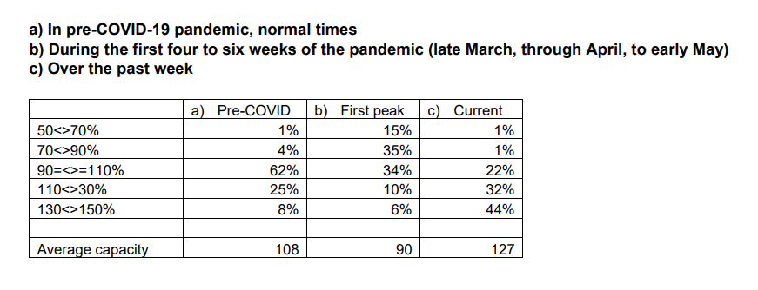

To what extent, if at all, would you say your experience of working in general practice during the COVID-19 pandemic has had an impact on your wellbeing?

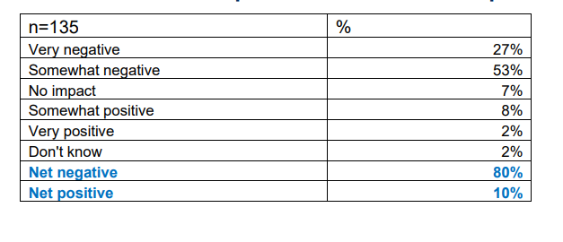
Which, if any, of the following wellbeing resources have you accessed?

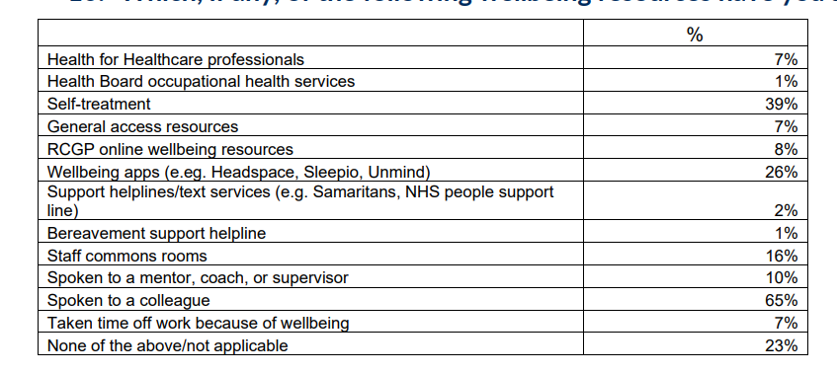

Still to learn:

- Pallative care planning for children in hospices and those dying at home
- Anything anecdotal to highlight experiences of families and loved ones of those experiences end of life crea between March 2020 and the lifting of restrictions in March 2022
- Any studies on the impact of restrictions on families and those receiving pallative care e.g terminal cancer patients
- Any studies or anecdoral evidence on health and wellbeing of staff

Dr Clifford Wyn Jones, Primary Care Director, Aneurin Bevan University Health Board [date?]
Dr Clifford Wyn Jones, Primary Care Director, Aneurin Bevan University Health Board [date?]
file:///C:/Users/rmiller/Downloads/workload%20in%20general%20practice%20survey%20results-wales-dec-2020.pdf

