Category – Practice Manager Award
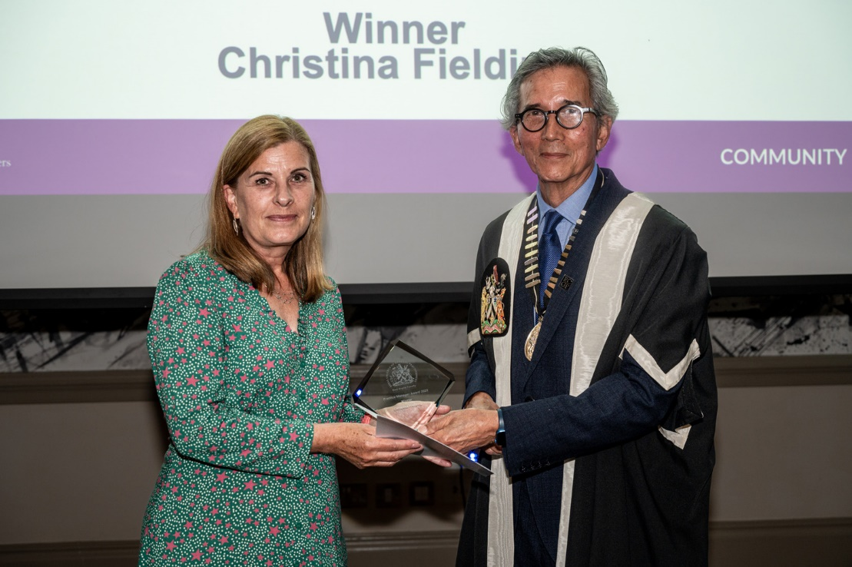
Prize Glass Engraved Plaque and Certificate
Please complete the application form below and email with attached evidence to: eanglia@rcgp.org.uk;
Closing date for entries – Wednesday, 4 September 2024, 12 noon.
This award is for the most outstanding contribution to Primary Care service provision or development by a Practice Manager in the preceding year.
The Awards process is overseen by a panel of judges made up of members of the RCGP East Anglia Faculty Board, both GPs and lay members. The judges will be looking for evidence such as:
- Commitment to patient care
- Innovative ideas
- Evidence of team work
- Details of personal qualities
- Commitment to work schedule and work colleagues. Commendation by patients and colleagues
- Evidence of work carried out beyond the call of duty
Examples of evidence include:
- Patient surveys and letters
- Written plans and outcomes for new ways of working or delivering care
- Colleague and staff feedback, formal and informal
- Evidence of personal development and work beyond role expectations
Application Form

Entry Details:

Category of Award PRACTICE MANAGER AWARD 2024

Name (person nominated) _______________________________________________

Job Title (person nominated) _______________________________________________

Contact email (person nominated) _______________________________________________

Your name and contact details
Name

Email Address

Telephone Number

Commitment to patient care (please give details below)

Innovative ideas (please give details below)

Evidence of team work (please give details below)

Details of personal qualities (please give details below)

Commitment to work schedule and work colleagues. Commendation by patients and colleagues (please give details below)

Evidence of work carried out beyond the call of duty (please give details below)

General Statement of Support (please give details below)

Please complete the application form and email with attached evidence to: eanglia@rcgp.org.uk;
Closing date for entries – Wednesday, 4 September 2024, 12 noon.

